MASSING ENVELOPE

//Date: 24-01-2019

//Authors: Jolt Wiersma, Michelle A. Menkiti, Arthur Masure

//Adapted from work by: Shervin Azadi, Dr.ir. Pirouz Nourian, Hans Hoogenboom

//Purpose: Merging voxel values from Obscurity and Visibility analysis to create one aggregated volume, and solar envelope

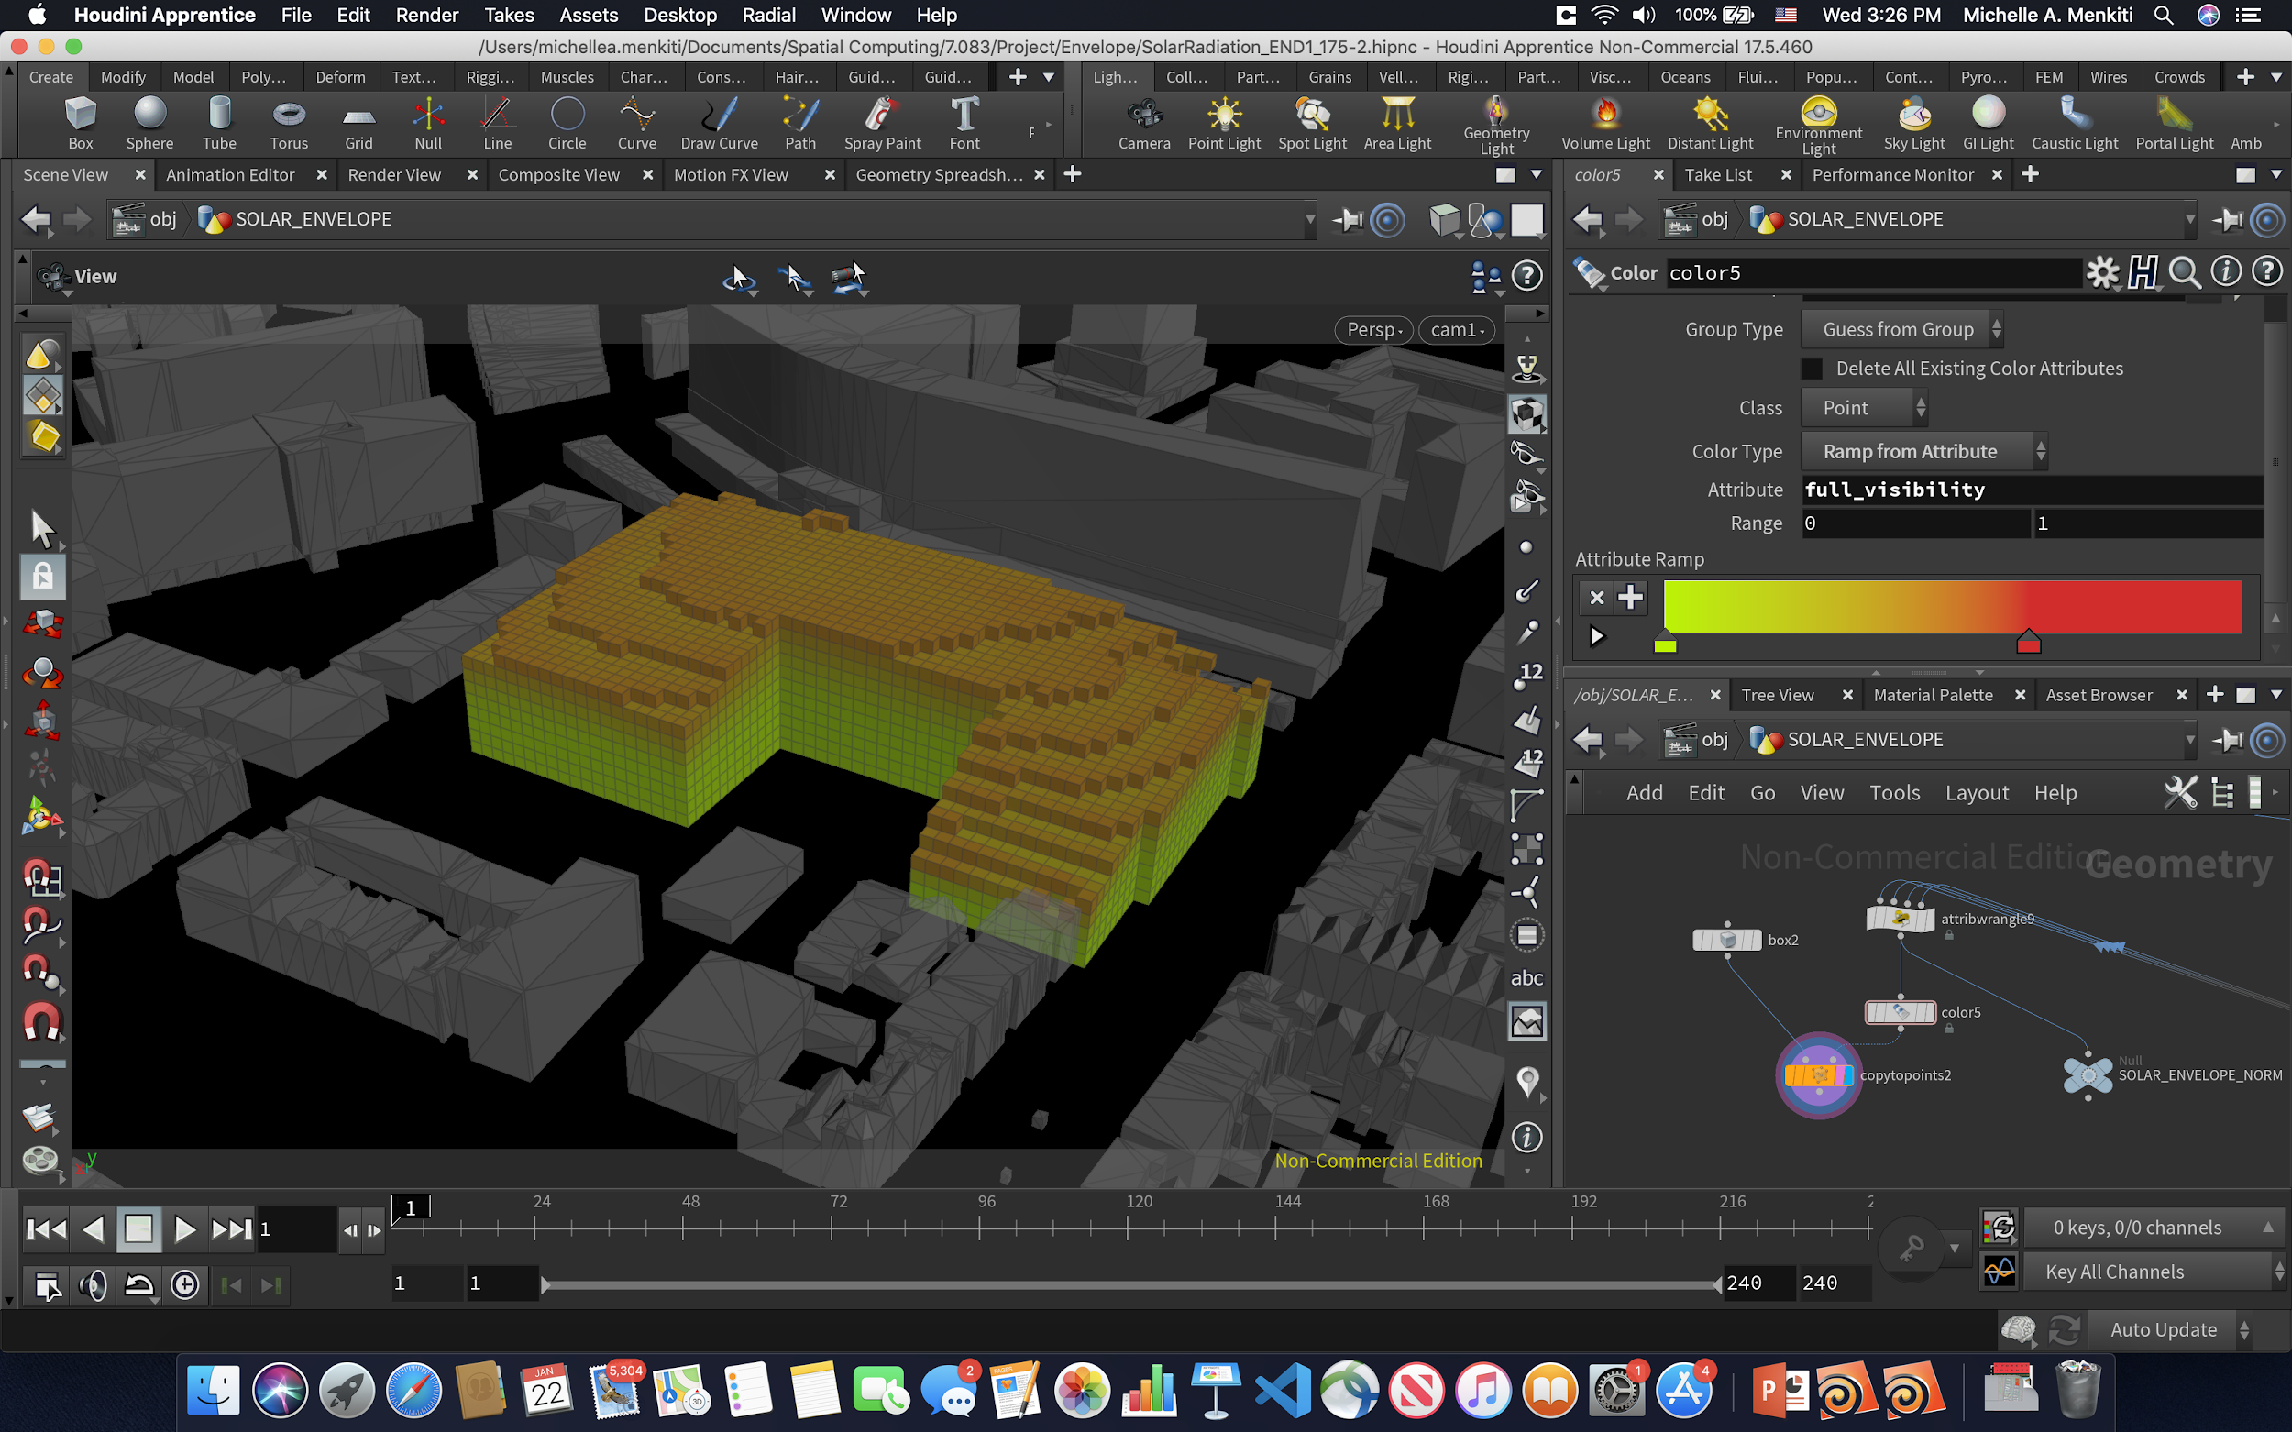

THE DESIRED MASSING ENVELOPE BASED ON DESIGN PRINCIPLES / STRATEGY

**WRANGLER 1**

**Normalizing all incoming values**

//INPUT 0 = OBSCURITY OF SKY

//INPUT 1 = OBSCURITY OF SUN

//INPUT 2 = VISIBILITY OF SKY

//INPUT 3 = VISIBILITY OF SUN

//RUN OVER DETAIL

int num_points = npoints(0);

float max_vsun = point(2,"visibility_sun",0);

float max_vsky = point(3,"visibility_sky",0);

float max_osky = point(0,"obscurity_sky",0);

float max_osun = point(1,"obscurity_sun",0);

float min_vsun = point(2,"visibility_sun",0);

float min_vsky = point(3,"visibility_sky",0);

float min_osky = point(0,"obscurity_sky",0);

float min_osun = point(1,"obscurity_sun",0);

for (int point = 0; point < num_points; point++)

{

float vsun_value = point(2,"visibility_sun",point);

float vsky_value = point(3,"visibility_sky",point);

float osky_value = point(0,"obscurity_sky",point);

float osun_value = point(1,"obscurity_sun",point);

if (vsun_value > max_vsun) max_vsun = vsun_value;

if (vsky_value > max_vsky) max_vsky = vsky_value;

if (osky_value > max_osky) max_osky = osky_value;

if (osun_value > max_osun) max_osun = osun_value;

if (vsun_value < min_vsun) min_vsun = vsun_value;

if (vsky_value < min_vsky) min_vsky = vsky_value;

if (osky_value < min_osky) min_osky = osky_value;

if (osun_value < min_osun) min_osun = osun_value;

}

for (int point = 0; point < num_points; point++)

{

float vsun_value = point(2,"visibility_sun",point);

float vsky_value = point(3,"visibility_sky",point);

float osky_value = point(0,"obscurity_sky",point);

float osun_value = point(1,"obscurity_sun",point);

vsun_value = fit(vsun_value, min_vsun, max_vsun, 0.001, 0.999);

vsky_value = fit(vsky_value, min_vsky, max_vsky, 0.001, 0.999);

osky_value = fit(osky_value, min_osky, max_osky, 0.001, 0.999);

osun_value = fit(osun_value, min_osun, max_osun, 0.001, 0.999);

//setting normalized values

setpointattrib(2,"visibility_sun",point,vsun_value,"set");

setpointattrib(3,"visibility_sky",point,vsky_value,"set");

setpointattrib(0,"obscurity_sky",point,osky_value,"set");

setpointattrib(1,"obscurity_sun",point,osun_value,"set");

}

**WRANGLER 2**

**Normalizing all incoming values**

//INPUT 0 = WRANGLER 1

//RUN OVER DETAIL

//getting inputs from sliders

float O_sky = ch("obscurity_sky");

float O_sun = ch("obscurity_sun");

float V_sun = ch("visibility_sun");

float V_sky = ch("visibility_sky");

//going through each input, and changing the value

//multiplying the normal values by the attribute values

int points = npoints(0);

for (int point = 0; point < points; point++)

{

//get attribute, divide it, replace it

//Obscurity_sky

float value1 = getattrib(0,"point","obscurity_sky",point,1);

value1 = pow(value1, O_sky);

//setpointattrib(0,"obscurity_sky",point,0,value1,"set");

//Obscurity_sun

float value2 = getattrib(0,"point","obscurity_sun",point,1);

value2 = pow(value2, O_sun);

//setpointattrib(0,"obscurity_sun",point,0,value2,"set");

//Visibility_sun

float value3 = getattrib(0,"point","visibility_sun",point,1);

value3 = pow(value3, V_sun);

//setpointattrib(0,"visibility_sun",point,0,value3,"set");

//Visibility_sky

float value4 = getattrib(0,"point","visibility_sky",point,1);

value4 = pow(value4, V_sky);

//setpointattrib(0,"visibility_sky",point,0,value4, "set");

//total

float total = value1 * value2 * value3 * value4;

//setting that value

setpointattrib(0,"full_visibility",point,total,"set");

}

**WRANGLER 3**

**Normalizing all incoming aggregate values**

//INPUT 0 = WRANGLER 2

//RUN OVER DETAIL

int num_points = npoints(0);

//setting temp max and min

float max_total = point(0,"full_visibility",0);

float min_total = point(0,"full_visibility",0);

//iterating through all points

for (int point = 0; point < num_points; point++)

{

float total_value = point(0,"full_visibility",point);

//adjusting values if new min and max are found

if (total_value > max_total) max_total = total_value;

if (total_value < min_total) min_total = total_value;

}

//iterating points

for (int point = 0; point < num_points; point++)

{

float total_value = point(0,"full_visibility",point);

total_value = fit(total_value, min_total, max_total, 0.001, 0.999);

//setting new attribute

setpointattrib(0,"full_visibility",point,total_value,"set");

}

**WRANGLER 4**

**Voxel removal**

//INPUT 0 = NORMALIZED VOXELS

//RUN OVER POINTS

//removing points if they are over a certain threshold

if (@full_visibility > chf("threshold"))

{

removepoint(0, @ptnum);

}